Vocational high school in computer programming

and innovation

**Team: WarShips**

**Petar Petkov**

**Stanislav Todorov**

**Krasiyana Kamburova**

**Dimitar Dyakov**

**Iliya Marinov**

**Todor Bozhinov**

**Table of content:**

1. **Authors**
2. **Purpose**
3. **Diagram**
4. **Main steps in the implementation of the project**
5. **Game conditions**
6. **Elements**

**6.1**

**6.2 Developer-Oriented**

**6.3 Developer Environment**

**1. Authors:**

* **Petar Petkov-** [**PGPetkov18@codingburgas.bg**](mailto:PGPetkov18@codingburgas.bg) **- Class XG**
* **Stanislav Todorov-** [**SATodorov18@codingburgas.bg**](mailto:SATodorov18@codingburgas.bg) **- Class XB**
* **Krasiyana Kamburova -** [**KSKamburova18@codingburgas.bg**](mailto:KSKamburova18@codingburgas.bg) **- Class XB**
* **Dimitar Dyakov –** [**dpdyakov18@codingburgas.bg**](mailto:dpdyakov18@codingburgas.bg) **– Class XV**
* **Iliya Marinov-** [**IMMarinov@codingburgas.bg**](mailto:IMMarinov@codingburgas.bg) **- Class XG**
* **Todor Bozhinov- TDBozhinov**[**18@codingburgas.bg**](mailto:18@codingburgas.bg) **- Class XB**

**2. Purpose:**

Our goal is to create an application that was developed on the basis of decoding and finding German ships during World War II.

**3. Diagram:**

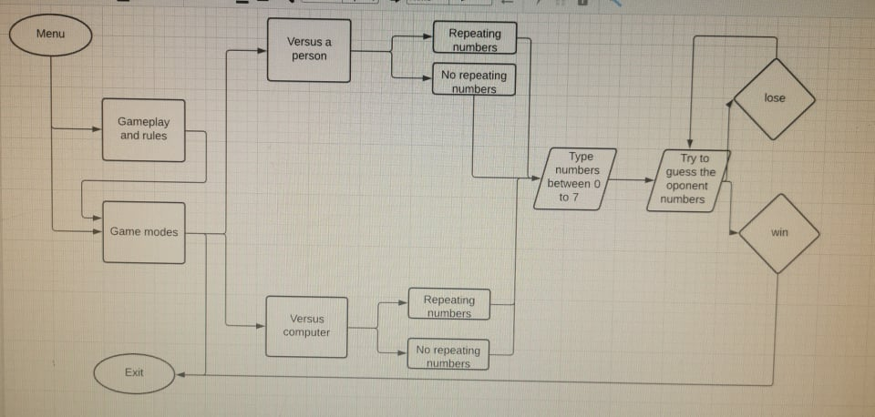

**4. Main steps in the implementation of the project:**

* Defining the main idea
* Defining the purpose of the project
* Implementing the project by writing code

The application is written in C++

**5. Game conditions:**

In our game we have a combination of 4 random numbers from 0 to 7. The player must try to guess his number with only 13 moves. If the player guesses the number, "Guessed numbers" must be displayed on his screen, and if he guesses a number at the correct position on the screen, "Guessed numbers and positions" must be displayed.

**6. Elements:**

**•** The structure of the application is as easy to use as possible.

**6.1:**

**•** Our application designed for the fun development of mathematical abilities.

**6.2 Developer-Oriented:**

* The biggest hurdle to rapid development is often not your development process, but how much time you spend focusing on the business logic of the function you are working on.

**6.3 Developer Environment:**

* *An example of an easy-to-work-with development environment:*

1. A developer clones a GitHub repo
2. He or she runs a couple of commands from a make file
3. Tests run
4. The application comes up and is accessible
5. Code changes are apparent in the running application